A screenshot of a cell phone

Description generated with very high confidence**Navigation Structure**

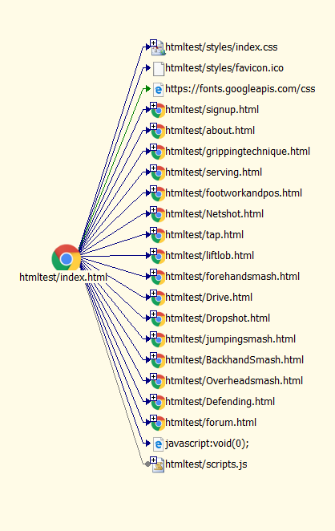Figure 1: Navigation structure

Figure 2: Site View Hyperlinks